Immersion Program Application
Please fill out and email to wayoftheearthschool@gmail.com
Or Mail to
319 Jay Carter Rd
Blue Hill, ME 04614
04614
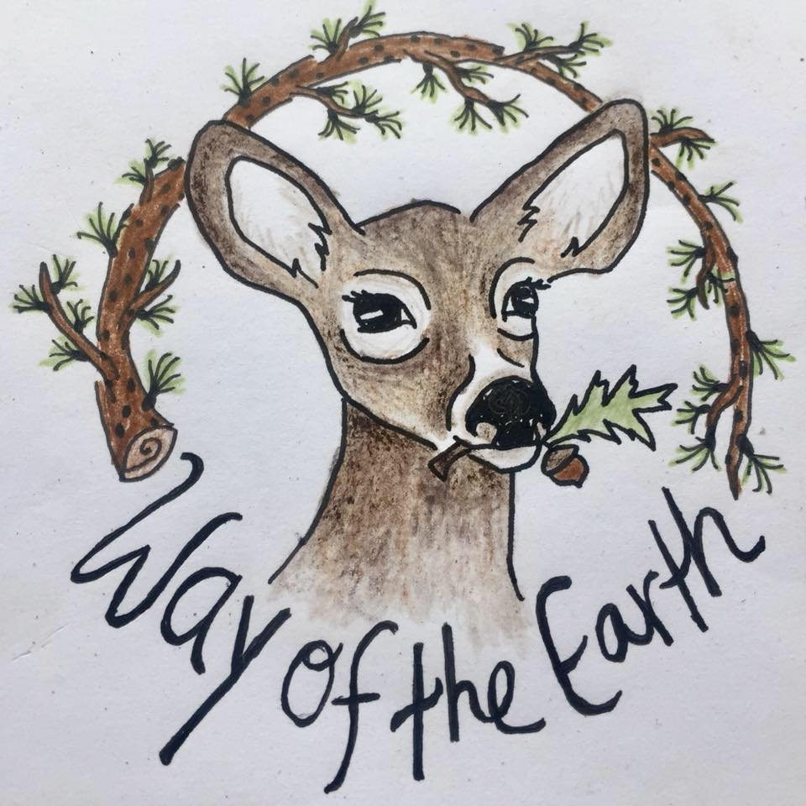

Name:
Preferred Pronoun:
Phone:
Mailing Address:

Date:
Birthday:
Email:

How did you hear about Way of the Earth?

1st Emergency contact name & relationship:
Phone #1:
Phone #2:
2nd Emergency contact name & relationship:
Phone #1:
Phone #2:
Do you have health insurance? If so, please attach a copy of your card.

Do you have dietary restrictions, allergies or injuries we should be aware of?

What are some of your past experiences, travels, jobs, or otherwise that you want to share with us? Fill out as many rows as you would like.

(you could attach a resume if you prefer)
Experience/Job
Description

What makes you want to sign up for this program?

What is your past experience, if any, with earth-living skills

Have you lived in a community before? If so, tell us a little bit about it

Are there any parts about community life you could see being difficult for you?

What are some aspects of community life that your excited about or curious to experience?

What is your relationship to substances?

Name a few plants, animals or other life that you feel close to or resonate with?

What are a few strong or emerging qualities in yourself that you love?

What are a few qualities in yourself that you struggle with?

Do you have any concerns or fears about doing a program like this?

What is something or someone that inspires you?

Which skills are most excited about learning?

Are transitions to a new environment difficult or easy for you?

What are your tendencies when dealing with conflict?

How do you feel about leaving your current situation, family, friends, etc, for 5 months? Do you feel supported in your decision to do so?

Anything else should be aware of?

